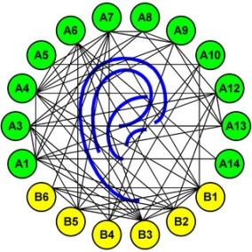

Sonderforschungsbereich/Transregio 31 “Das aktive Gehör”

Einladung

zum Vortrag im Rahmen des Seminars des SFB/TRR 31

Freitag, 20. Januar 2012, 14 Uhr c.t.

im Raum W2 1-143 der Universität Oldenburg
und Raum H28 / R 2.31 med. Campus Magdeburg,
(per Videoübertragung)

“Neuroimaging of tinnitus”

Prof. Pim van Dijk
University Medical Centre Groningen
Tinnitus is a very common and potentially devastating condition. In many patients, tinnitus is just a mild inconvenience. However, in severe cases, tinnitus is associated with lack of sleep and concentration, anxiety and depression, leading to reduced participation in society. At present the physiopathology of tinnitus is unknown, and no cure exists. Tinnitus is often associated with hearing loss. Animal models of tinnitus suggest that it is associated with changes in the brain activity as a result of peripheral hearing loss. For example, noise induced hearing loss leads to increased spontaneous activity in auditory brain centers. We study brain activity and anatomy in human subjects with tinnitus. Our neuroimaging work on tinnitus aims at translating the results in lab animals to human subjects, by the application of functional and structural MRI. Results: (1) We found that tinnitus is associated with gray matter changes in auditory and non-auditory brain structure. This suggest that tinnitus is either associated with a pre-existing condition in the brain, or that tinnitus changes the anatomical characteristics of the brain. (2) In contrast to a hypothesis based on the animal work, we found that tinnitus in humans can occur without functional reorganization of the tonotopic map of the auditory cortex. This may be interpreted as support for alternative mechanisms in tinnitus generation, e.g. homeostatic plasticity.

